SUNIL DOGRA 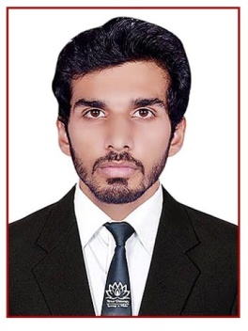
B.Tech. (Civil Engineering)
Contact No. : - 7734019484
E-mail :- sunildogra35@gmail.com

CAREER OBJECTIVE

To work in a firm with a professional work driven environment where I can utilize and apply my knowledge, skills which would enable me to grow while fulfilling organizational goals.

BASIC ACADEMIC CREDENTIALS

Qualification | Board/University | Year | Percentage
B.Tech (Civil Engineering) | Mewar University | 2013-2017 | 82.90%
Intermediate | ST. Peter’s Higher Secondary School | 2013 | 68.60%
High School | ST. Mary’s Convent High School | 2011 | 73.60%

EXPERIENTIAL LEARNING (SUMMER TRAINING PROGRAM)

    - Company Name :- Amrapali Groups
    - Project Title :- Practical Training(Field Training)
    - Duration :- One Months (29th May’16 to 25th june’16)

COMPUTER SKILLS

- Microsoft Office Word, Microsoft Office Excel, Microsoft Office Power Point
- Internet Browsing
- Auto CAD 2013

LEARNING

- Attended a guest lecture on Trenchless Technology
- Attended a guest lecture on Waste Management
- Attended a guest lecture on Renewable Resources

INTERPERSONAL SKILL

  - Sincere, Fast Learner, Patience
  - Interested in updating knowledge through continuous learning.
  - Good Communication Skills

CERTIFICATE

- Training certificate for Amrapali Groups

PERSONAL DETAILS

- Father’s Name :- Tarsem Lal
- Permanent Address :- Old Mhada ,Andheri West, Mumbai
- Date of Birth :- 13th August 1994
- Language Known :- English, Hindi, and Punjabi
- Marital Status :- Single
- Nationality/Religion :- Indian / Hindu
- Interest & Hobbies :- Internet browsing ,singing, playing football

DECLARATION

I do hereby declare that the above information is true to the best of my knowledge.

Sunil Dogra
(Signature)

